LEMUEL V

727722EUCS512

CIA-2

3)

Repo:

package com.Lemuel.app.repo;

import org.springframework.data.jpa.repository.JpaRepository;

import com.Lemuel.app.entity.Stud;

public interface StudRepo extends JpaRepository<Stud, Integer> {

}

Entity:

package com.Lemuel.app.entity;

import jakarta.persistence.Column;

import jakarta.persistence.Entity;

import jakarta.persistence.Id;

import jakarta.persistence.Table;

@Table(name="people")

@Entity

public class Stud {

@Id

@Column(name="StudentId")

private int StudentId;

@Column(name="StudentName")

private String StudentName;

@Column(name="Age")

private int Age;

public int getStudentId() {

return StudentId;

}

public void setStudentId(int studentId) {

StudentId = studentId;

}

public String getStudentName() {

return StudentName;

}

public void setStudentName(String studentName) {

StudentName = studentName;

}

public int getAge() {

return Age;

}

public void setAge(int age) {

Age = age;

}

public Stud(int studentId, String studentName, int age) {

super();

StudentId = studentId;

StudentName = studentName;

Age = age;

}

public Stud() {

}

}

Controller:

package com.Lemuel.app.controller;

import java.util.List;

import java.util.Optional;

import org.springframework.beans.factory.annotation.Autowired;

import org.springframework.web.bind.annotation.DeleteMapping;

import org.springframework.web.bind.annotation.GetMapping;

import org.springframework.web.bind.annotation.PathVariable;

import org.springframework.web.bind.annotation.PostMapping;

import org.springframework.web.bind.annotation.PutMapping;

import org.springframework.web.bind.annotation.RequestBody;

import org.springframework.web.bind.annotation.RestController;

import com.Lemuel.app.entity.Stud;

import com.Lemuel.app.service.StudService;

@RestController

public class StudController {

@Autowired

private StudService stse;

@GetMapping ("/getStud")

public List<Stud>getDetails()

{

return stse.getAllDetails();

}

@GetMapping ("/getStud/{StudentId}")

public Optional<Stud> getDetails(@PathVariable int StudentId)

{

return stse.getAllDetails(StudentId);

}

@PostMapping("/addStud")

public Stud postDetails (@RequestBody Stud s)

{

return stse.addDetails(s);

}

@PutMapping("/putStud/{StudentId}")

public String putDetails(@RequestBody Stud s ) {

return stse.changeDetails(s);

}

@DeleteMapping("/delStud/{StudentId}")

public String deletedetails(@PathVariable("StudentId") int StudentId)

{

return stse.deleteDetails(StudentId);

}

}

Service:

package com.Lemuel.app.service;

import java.util.List;

import java.util.Optional;

import org.springframework.beans.factory.annotation.Autowired;

import org.springframework.stereotype.Service;

import com.Lemuel.app.entity.Stud;

import com.Lemuel.app.repo.StudRepo;

@Service

public class StudService {

@Autowired

private StudRepo stu;

public Stud addDetails(Stud s)

{

return stu.save(s);

}

public List<Stud>getAllDetails()

{

return stu.findAll();

}

public Optional<Stud> getAllDetails(int StudentId)

{

return stu.findById(StudentId);

}

public String changeDetails(Stud s) {

stu.save(s);

return "updated";

}

public String deleteDetails(int StudentId)

{

stu.deleteById(StudentId);

return "deleted";

}

}

OUTPUT:

GET:

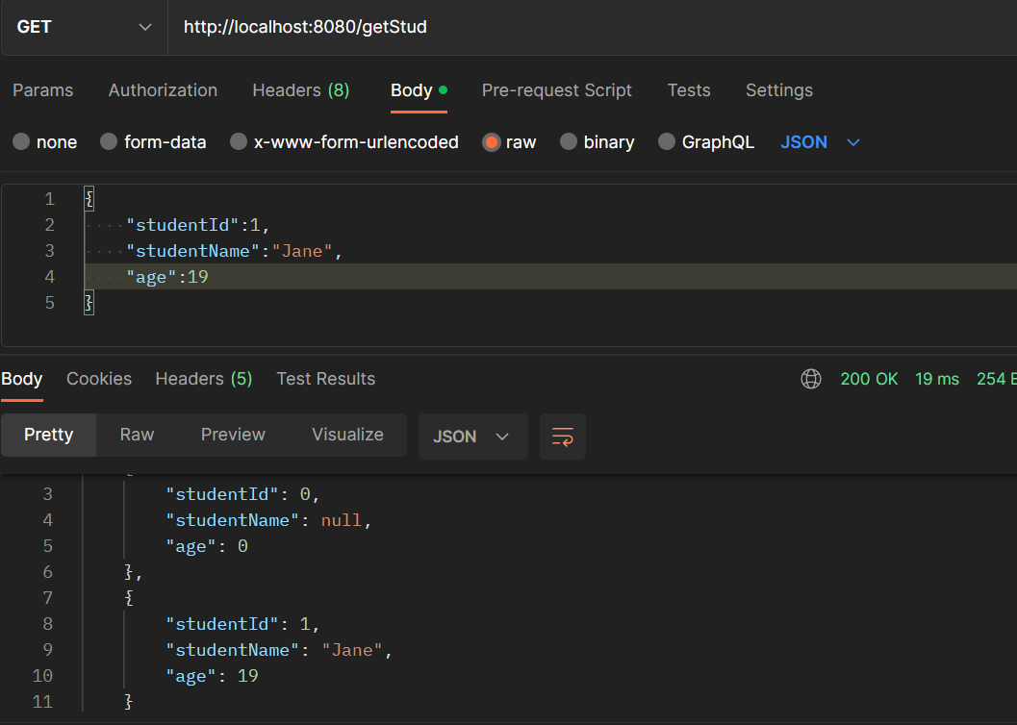

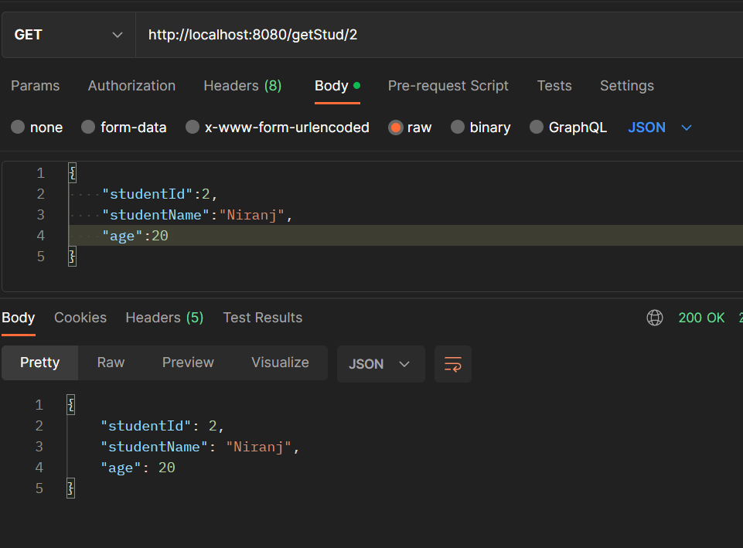

POST:

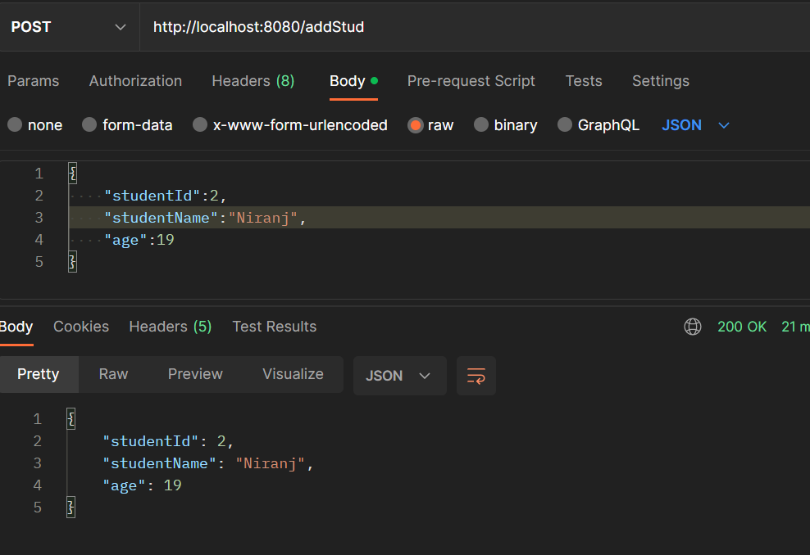

PUT:

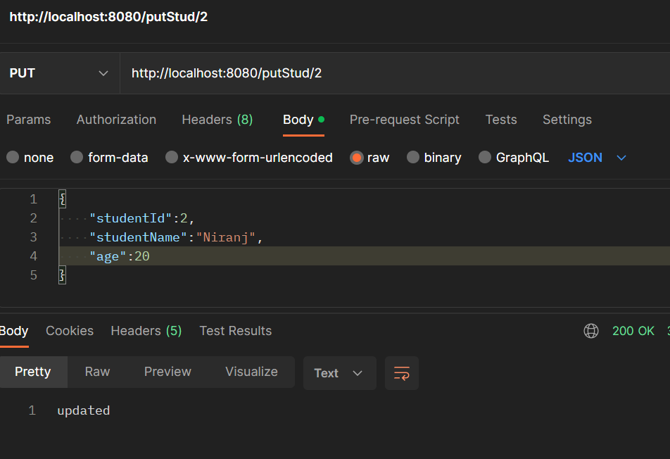

DELETE:

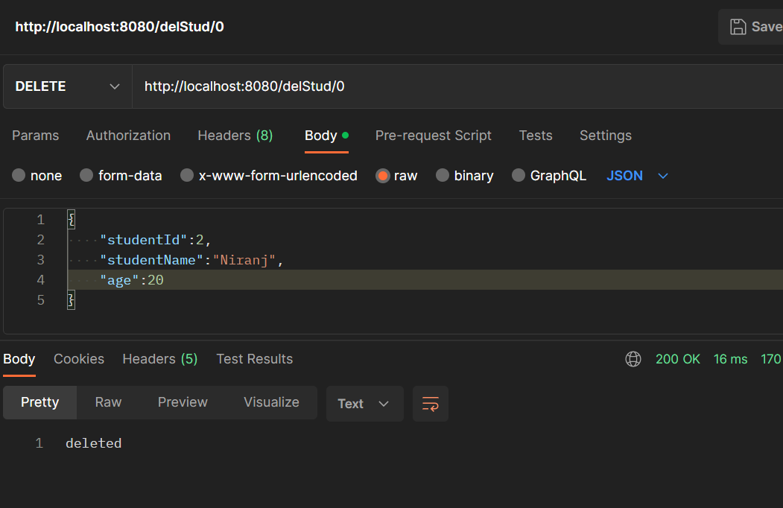

2)

Repo:

package com.Lemuel.app2.repo;

import java.util.List;

import org.springframework.data.jpa.repository.JpaRepository;

import org.springframework.data.jpa.repository.Query;

import org.springframework.data.repository.query.Param;

import com.Lemuel.app2.entity.Bike;

publicinterfaceBikeRepoextendsJpaRepository<Bike,Integer>{

*@Query*("select a from App a where a.bikeName = :bikename")

List<Bike>findByName(*@Param*("bikename")Stringbikename);

*@Query*("select a from App a where a.year = :year")

List<Bike>findByYear(*@Param*("year")intyear);

*@Query*("select a from App a where a.year = :year and a.bikeName = :bikename")

List<Bike>findDetails(*@Param*("year")intyear,*@Param*("bikename")Stringbikename);

}

Entity:

package com.Lemuel.app2.entity;

import jakarta.persistence.Column;

import jakarta.persistence.Entity;

import jakarta.persistence.Id;

import jakarta.persistence.Table;

*@Table*(name="bike")

*@Entity*

publicclassBike{

*@Id*

*@Column*(name="bikeId")

privateintbikeId;

*@Column*(name="regNumber")

privateStringregNumber;

*@Column*(name="ownerName")

privateStringownerName;

*@Column*(name="year")

privateintyear;

*@Column*(name="bikeName")

privateStringbikeName;

*@Column*(name="modelName")

privateStringmodelName;

publicintgetBikeId(){

returnbikeId;

}

publicvoidsetBikeId(intbikeId){

this.bikeId=bikeId;

}

publicStringgetRegNumber(){

returnregNumber;

}

publicvoidsetRegNumber(StringregNumber){

this.regNumber=regNumber;

}

publicStringgetOwnerName(){

returnownerName;

}

publicvoidsetOwnerName(StringownerName){

this.ownerName=ownerName;

}

publicintgetYear(){

returnyear;

}

publicvoidsetYear(intyear){

this.year=year;

}

publicStringgetBikeName(){

returnbikeName;

}

publicvoidsetBikeName(StringbikeName){

this.bikeName=bikeName;

}

publicStringgetModelName(){

returnmodelName;

}

publicvoidsetModelName(StringmodelName){

this.modelName=modelName;

}

publicBike(intbikeId,StringregNumber,StringownerName,intyear,StringbikeName,StringmodelName){

super();

this.bikeId=bikeId;

this.regNumber=regNumber;

this.ownerName=ownerName;

this.year=year;

this.bikeName=bikeName;

this.modelName=modelName;

}

publicBike(){

}

}

Controller:

package com.Lemuel.app2.controller;

import java.util.List;

import org.springframework.beans.factory.annotation.Autowired;

import org.springframework.web.bind.annotation.GetMapping;

import org.springframework.web.bind.annotation.PathVariable;

import org.springframework.web.bind.annotation.PostMapping;

import org.springframework.web.bind.annotation.RequestBody;

import org.springframework.web.bind.annotation.RestController;

import com.Lemuel.app2.entity.Bike;

import com.Lemuel.app2.service.BikeService;

*@RestController*

publicclassBikeController{

*@Autowired*BikeServices;

*@PostMapping*("/")

publicBikepostDetails(*@RequestBody*Bikeb)

{

returns.addDetails(b);

}

*@GetMapping*("/bikename/{bikename}")

publicList<Bike>getDetailsWithJp(*@PathVariable*Stringbikename)

{

returns.findJPQuery(bikename);

}

*@GetMapping*("/year/{year}")

publicList<Bike>getDetailsWithJp(*@PathVariable*intyear)

{

returns.findJPQuery(year);

}

*@GetMapping*("/year/{year}/bikename/{bikename}")

publicList<Bike>getDetailsWithJp(*@PathVariable*intyear,*@PathVariable*Stringbikename)

{

returns.findJPQuery(year,bikename);

}

}

Service:

package com.Lemuel.app2.service;

import java.util.List;

import org.springframework.beans.factory.annotation.Autowired;

import org.springframework.stereotype.Service;

import com.Lemuel.app2.entity.Bike;

import com.Lemuel.app2.repo.BikeRepo;

*@Service*

publicclassBikeService{

*@Autowired*

privateBikeReporep;

publicBikeaddDetails(Bikeb)

{

returnrep.save(b);

}

publicList<Bike>findJPQuery(StringbikeName)

{

returnrep.findByName(bikeName);

}

publicList<Bike>findJPQuery(intyear)

{

returnrep.findByYear(year);

}

publicList<Bike>findJPQuery(intyear,StringbikeName)

{

returnrep.findDetails(year,bikeName);

}

}

OUTPUT:

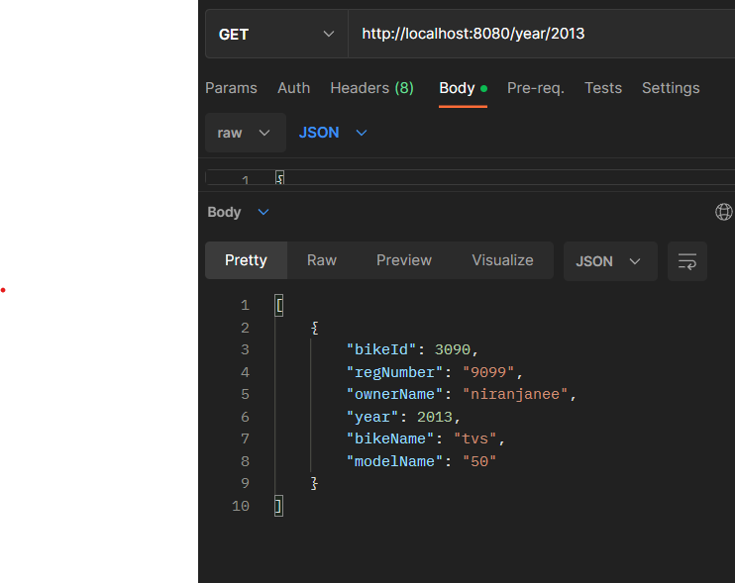

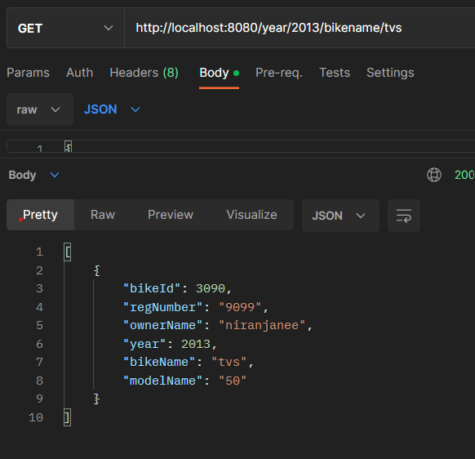

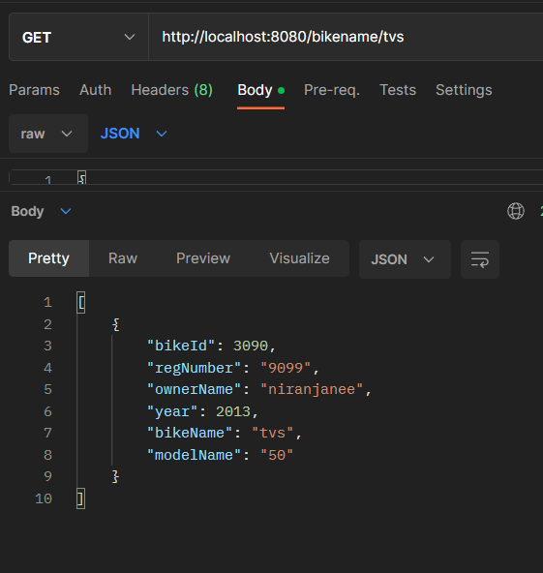

5)

Repo:

package com.Lemuel.app.repo;

import org.springframework.data.jpa.repository.JpaRepository;

import com.Lemuel.app.entity.Employee;

publicinterfaceRepoextendsJpaRepository<Employee,Integer>{

}

Entity:

package com.Lemuel.app.entity;

import jakarta.persistence.Entity;

import jakarta.persistence.Id;

import jakarta.persistence.Table;

*@Table*(name="office")

*@Entity*

publicclassEmployee{

*@Id*

privateintemployeeId;

privateStringfirstName;

privateStringlastName;

privateStringemail;

privateintmobile;

privateStringaddress;

publicintgetEmployeeId(){

returnemployeeId;

}

publicvoidsetEmployeeId(intemployeeId){

this.employeeId=employeeId;

}

publicStringgetFirstName(){

returnfirstName;

}

publicvoidsetFirstName(StringfirstName){

this.firstName=firstName;

}

publicStringgetLastName(){

returnlastName;

}

publicvoidsetLastName(StringlastName){

this.lastName=lastName;

}

publicStringgetEmail(){

returnemail;

}

publicvoidsetEmail(Stringemail){

this.email=email;

}

publicintgetMobile(){

returnmobile;

}

publicvoidsetMobile(intmobile){

this.mobile=mobile;

}

publicStringgetAddress(){

returnaddress;

}

publicvoidsetAddress(Stringaddress){

this.address=address;

}

publicEmployee(){

}

publicEmployee(intemployeeId,StringfirstName,StringlastName,Stringemail,intmobile,Stringaddress){

super();

this.employeeId=employeeId;

this.firstName=firstName;

this.lastName=lastName;

this.email=email;

this.mobile=mobile;

this.address=address;

}

}

Controller:

package com.Lemuel.app.controller;

import java.util.List;

import java.util.Optional;

import org.springframework.beans.factory.annotation.Autowired;

import org.springframework.web.bind.annotation.GetMapping;

import org.springframework.web.bind.annotation.PathVariable;

import org.springframework.web.bind.annotation.PostMapping;

import org.springframework.web.bind.annotation.RequestBody;

import com.Lemuel.app.entity.Employee;

import com.Lemuel.app.service.Service;

publicclassController{

*@Autowired*

privateServices;

*@GetMapping*("/getEmp")

publicList<Employee>getDetails()

{

returns.getAllDetails();

}

*@GetMapping*("/getEmp/{employeeId}")

publicOptional<Employee>getDetails(*@PathVariable*intemployeeId)

{

returns.getAllDetails(employeeId);

}

*@PostMapping*("/addEmp")

publicEmployeepostDetails(*@RequestBody*Employeee)

{

returns.addDetails(e);

}

}

Service:

package com.Lemuel.app.service;

import java.util.List;

import org.springframework.beans.factory.annotation.Autowired;

import org.springframework.boot.autoconfigure.data.web.SpringDataWebProperties.Sort;

import org.springframework.data.domain.Page;

import org.springframework.data.domain.PageRequest;

import org.springframework.data.domain.Pageable;

import com.Lemuel.app.entity.Employee;

import com.Lemuel.app.repo.Repo;

publicclassService{

*@Autowired*

privateRepoemp;

publicList<Employee>getDetails(intpgno,

intpgsize){

Pageablepg=PageRequest.*of*(pgno,pgsize);

Page<Employee>pagedResult=emp.findAll(pg);

List<Employee>products=pagedResult.getContent();

returnproducts;

}

publicList<Employee>findProductsWithSorting(Stringfield){

returnemp.findAll(Sort.by(Sort.Direction.ASC,field));

}

publicEmployeesaveDetails(Employees)

{

returnemp.save(s);

}

}

OUTPUT:

Sort:

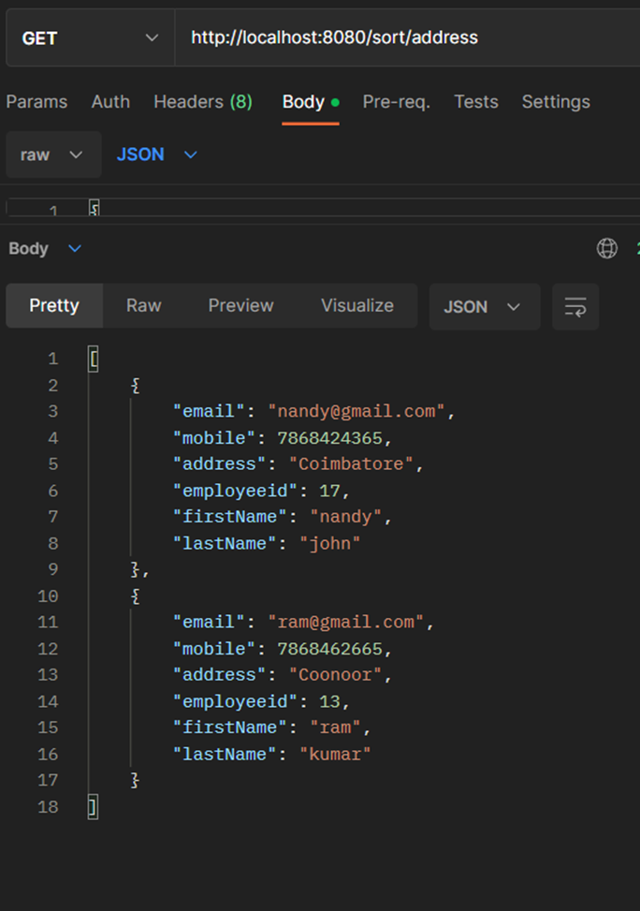

Page:

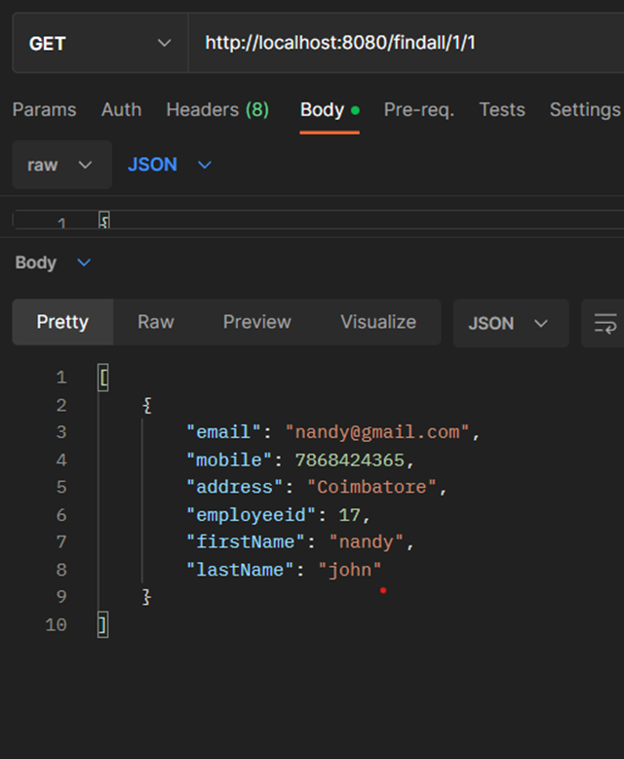

4)

ApiController:

**package** com.example.demo.controller;

**import** java.util.List;

**import** java.util.Optional;

**import**org.springframework.beans.factory.annotation.Autowired;

**import** org.springframework.web.bind.annotation.GetMapping;

**import** org.springframework.web.bind.annotation.PathVariable;

**import** org.springframework.web.bind.annotation.PostMapping;

**import** org.springframework.web.bind.annotation.RequestBody;

**import** org.springframework.web.bind.annotation.RestController;

**import** com.example.demo.model.Owner;

**import** com.example.demo.request.ApiRequest;

**import** com.example.demo.service.ApiService;

@RestController

**publicclass** ApiController {

@Autowired

ApiService service;

@PostMapping("/")

**publicboolean** addOwner(@RequestBody ApiRequest request) {

**return**service.addOwner(request);

}

@GetMapping("/")

**public** List<Owner> getOwner(){

**return**service.getOwner();

}

@GetMapping("/{id}")

**public** Optional<Owner> getOwnerById(@PathVariable**int**id){

**return**service.getOwnerById(id);

}

}

Entity:

Owner.java

**package** com.example.demo.model;

**import** jakarta.persistence.Entity;

**import** jakarta.persistence.GeneratedValue;

**import** jakarta.persistence.GenerationType;

**import** jakarta.persistence.Id;

**import** jakarta.persistence.OneToOne;

@Entity

**publicclass** Owner {

@Id

@GeneratedValue(strategy=GenerationType.***IDENTITY***)

**privateint**ownerId;

@Override

**public** String toString() {

**return**"Owner [ownerId=" + ownerId + ", ownerName=" + ownerName + ", address=" + address + ", mobile=" + mobile

+ ", shop=" + shop + "]";

}

**publicint** getOwnerId() {

**return**ownerId;

}

**publicvoid** setOwnerId(**int**ownerId) {

**this**.ownerId = ownerId;

}

**public** String getOwnerName() {

**return**ownerName;

}

**publicvoid** setOwnerName(String ownerName) {

**this**.ownerName = ownerName;

}

**public** String getAddress() {

**return**address;

}

**publicvoid** setAddress(String address) {

**this**.address = address;

}

**publiclong** getMobile() {

**return**mobile;

}

**publicvoid** setMobile(**long**mobile) {

**this**.mobile = mobile;

}

**public** Shop getShop() {

**return**shop;

}

**publicvoid** setShop(Shop shop) {

**this**.shop = shop;

}

**private** String ownerName;

**private** String address;

**privatelong**mobile;

@OneToOne

**private** Shop shop;

}

Shop.java

**package** com.example.demo.model;

**import** jakarta.persistence.Entity;

**import** jakarta.persistence.GeneratedValue;

**import** jakarta.persistence.GenerationType;

**import** jakarta.persistence.Id;

@Entity

**publicclass** Shop {

@Id

@GeneratedValue(strategy=GenerationType.***IDENTITY***)

**privateint**shopId;

@Override

**public** String toString() {

**return**"Shop [shopId=" + shopId + ", shopName=" + shopName + ", place=" + place + ", typesAvailable="

+ typesAvailable + "]";

}

**publicint** getShopId() {

**return**shopId;

}

**publicvoid** setShopId(**int**shopId) {

**this**.shopId = shopId;

}

**public** String getShopName() {

**return**shopName;

}

**publicvoid** setShopName(String shopName) {

**this**.shopName = shopName;

}

**public** String getPlace() {

**return**place;

}

**publicvoid** setPlace(String place) {

**this**.place = place;

}

**publicint** getTypesAvailable() {

**return**typesAvailable;

}

**publicvoid** setTypesAvailable(**int**typesAvailable) {

**this**.typesAvailable = typesAvailable;

}

**private** String shopName;

**private** String place;

**privateint**typesAvailable;

}

Repository

OwnerRepo.java

**package** com.example.demo.repository;

**import** org.springframework.data.jpa.repository.JpaRepository;

**import**org.springframework.stereotype.Repository;

**import** com.example.demo.model.Owner;

@Repository

**publicinterface** OwnerRepo **extends** JpaRepository<Owner, Integer> {

}

ShopRepository.java

**package** com.example.demo.repository;

**import** org.springframework.data.jpa.repository.JpaRepository;

**import**org.springframework.stereotype.Repository;

**import** com.example.demo.model.Shop;

@Repository

**publicinterface** ShopRepository **extends** JpaRepository<Shop, Integer> {

}

Service

**package** com.example.demo.service;

**import** java.util.List;

**import** java.util.Optional;

**import** org.springframework.beans.factory.annotation.Autowired;

**import** org.springframework.stereotype.Service;

**import** org.springframework.web.bind.annotation.RequestBody;

**import** com.example.demo.model.Owner;

**import** com.example.demo.model.Shop;

**import** com.example.demo.repository.OwnerRepo;

**import**com.example.demo.repository.ShopRepository;

**import** com.example.demo.request.ApiRequest;

@Service

**publicclass** ApiService {

@Autowired

OwnerRepo ownerRepo;

@Autowired

ShopRepositoryshopRepo;

**publicboolean** addOwner(@RequestBody ApiRequest request) {

Shop shop=**new** Shop();

shop.setShopName(request.getShopName());

shop.setPlace(request.getPlace());

shop.setTypesAvailable(request.getTypesAvailable());

shop=shopRepo.save(shop);

Owner owner=**new** Owner();

owner.setOwnerName(request.getOwnerName());

owner.setAddress(request.getAddress());

owner.setMobile(request.getMobile());

owner.setShop(shop);

ownerRepo.save(owner);

**returntrue**;

}

**public** List<Owner> getOwner() {

**return**ownerRepo.findAll();

}

**public** Optional<Owner> getOwnerById(**int**id) {

**return**ownerRepo.findById(id);

}

}

OUTPUT:

1)

Repo:

package com.Lemuel.app.repo;

import org.springframework.data.jpa.repository.JpaRepository;

import com.Lemuel.app.entity.Marathon;

publicinterfaceRepoextendsJpaRepository<Marathon,Integer>{

}

Marathon.java:

package com.Lemuel.app.entity;

*@*Table(name="marathon")

*@*Entity

publicclassMarathon{

*@*Id

privateintmarathonId;

privateStringmarathonName;

privateintDistance;

privateStringParticipant;

publicintgetMarathonId(){

returnmarathonId;

}

publicvoidsetMarathonId(intmarathonId){

this.marathonId=marathonId;

}

publicStringgetMarathonName(){

returnmarathonName;

}

publicvoidsetMarathonName(StringmarathonName){

this.marathonName=marathonName;

}

publicintgetDistance(){

returnDistance;

}

publicvoidsetDistance(intdistance){

Distance=distance;

}

publicStringgetParticipant(){

returnParticipant;

}

publicvoidsetParticipant(Stringparticipant){

Participant=participant;

}

publicMarathon(intmarathonId,StringmarathonName,intdistance,Stringparticipant){

super();

this.marathonId=marathonId;

this.marathonName=marathonName;

Distance=distance;

Participant=participant;

}

publicMarathon(){

}

}

Participants.java:

package com.Lemuel.app.entity;

*@*Table(name="par")

*@*Entity

publicclassParticipants{

*@*Id

privateintparticipantId;

privateStringName;

privateintage;

privateintnumber;

publicintgetParticipantId(){

returnparticipantId;

}

publicvoidsetParticipantId(intparticipantId){

this.participantId=participantId;

}

publicStringgetName(){

returnName;

}

publicvoidsetName(Stringname){

Name=name;

}

publicintgetAge(){

returnage;

}

publicvoidsetAge(intage){

this.age=age;

}

publicintgetNumber(){

returnnumber;

}

publicvoidsetNumber(intnumber){

this.number=number;

}

publicParticipants(intparticipantId,Stringname,intage,intnumber){

super();

this.participantId=participantId;

Name=name;

this.age=age;

this.number=number;

}

publicParticipants(){

}

}

Service:

package com.example.demo.Service;  
  
import java.util.List;  
  
  
import org.springframework.beans.factory.annotation.Autowired;  
import org.springframework.stereotype.Service;  
  
import com.example.demo.Repository.MarathonRepo;  
import com.example.demo.entity.Marathon;  
  
  
  
  
  
@Service  
public class ApiService {  
@Autowired  
private MarathonRepo rp;  
public Marathon saveDetails(Marathon f) {  
return rp.save(f);  
}  
public List <Marathon> getAllDetails(){  
return rp.findAll();  
}  
}

Controller:

package com.example.demo.Controller;  
  
import java.util.List;  
  
import org.springframework.beans.factory.annotation.Autowired;  
  
import org.springframework.web.bind.annotation.GetMapping;  
  
import org.springframework.web.bind.annotation.PostMapping;  
import org.springframework.web.bind.annotation.RequestBody;  
import org.springframework.web.bind.annotation.RestController;  
  
import com.example.demo.Service.ApiService;  
import com.example.demo.entity.Marathon;  
  
  
  
@RestController  
  
public class ApiController {  
@Autowired  
private ApiService Aservice;  
  
@PostMapping("/post")  
public String getDetails(@RequestBody Marathon s ) {  
Aservice.saveDetails(s);  
return "Value added";  
}  
    @GetMapping("/get")  
public List <Marathon> getDetails(){  
return Aservice.getAllDetails();  
}  
  
}